Independent T-tests

1. Type your data going down in column 1.
2. In column 2, type which group a person is in. For example, if the first person (in row 1) is in group 1, give them a “1” in the second column.
   1. You should have at least 2 groups of people listed in column 2.
3. 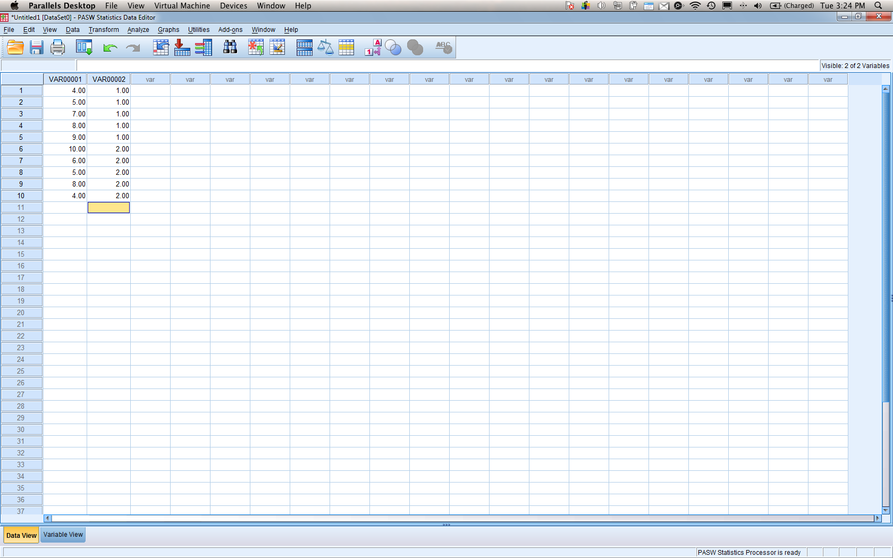
4. Analyze > compare means > independent t-test.
5. 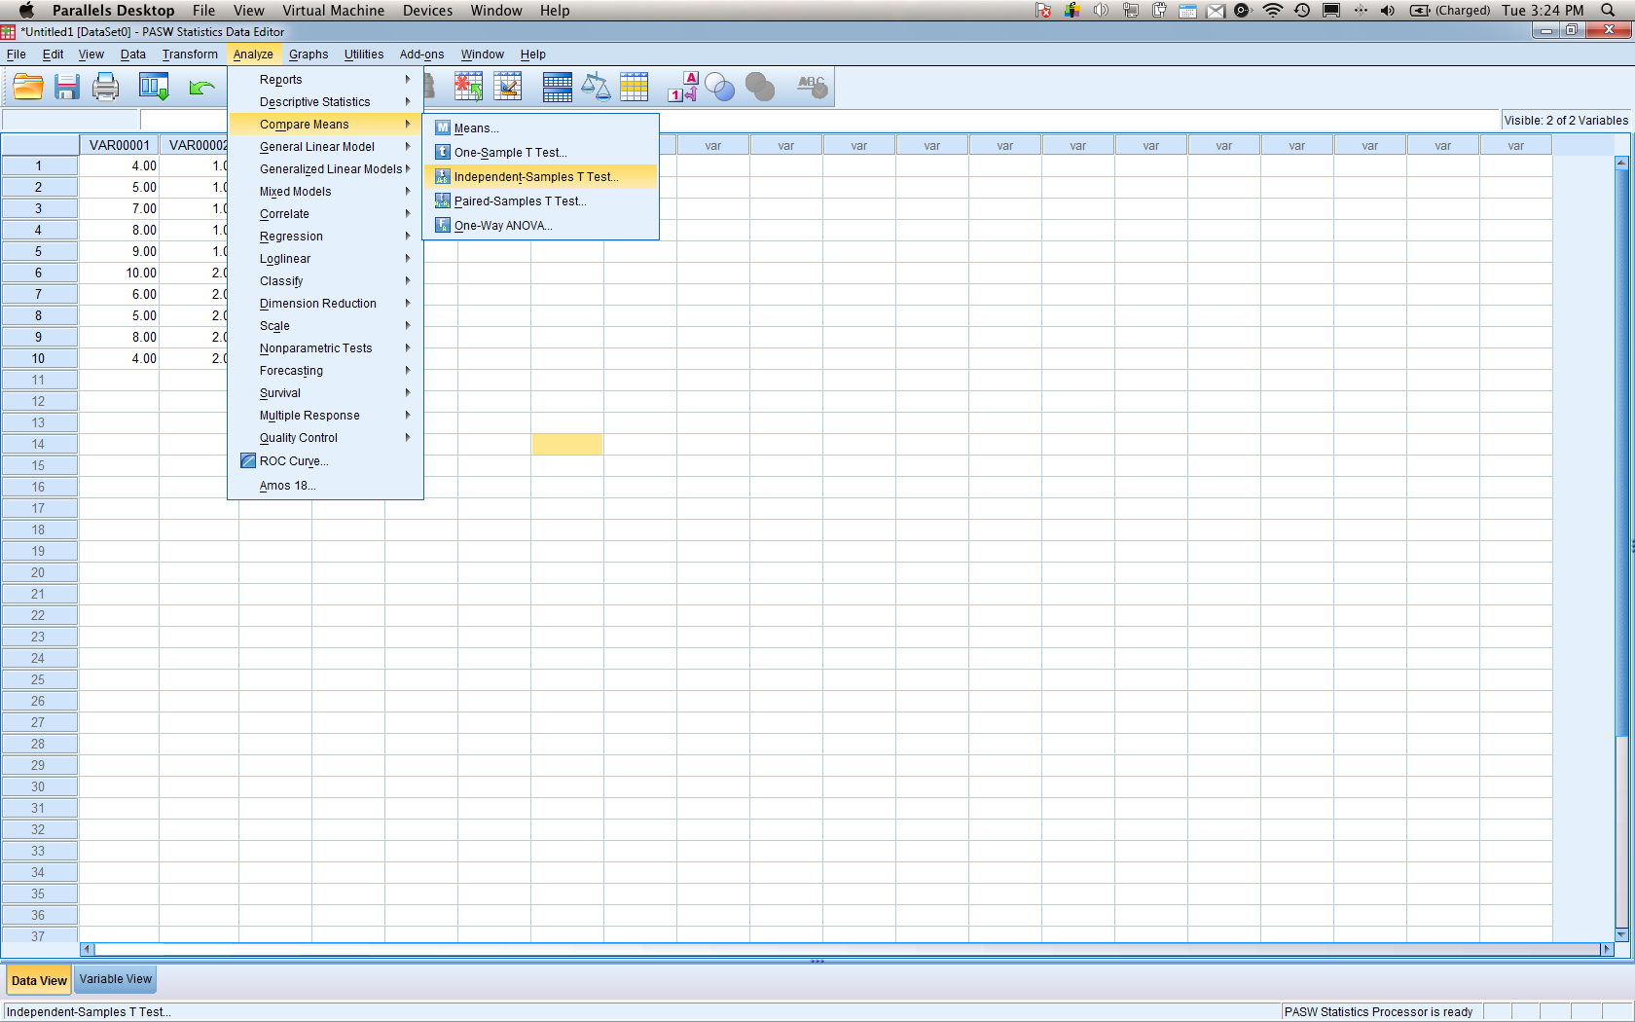
6. First, move the variable with the data in it (column 1 here) into the first box.
   1. Second move the variable with the group information (column 2 here) into the grouping variable box.
7. 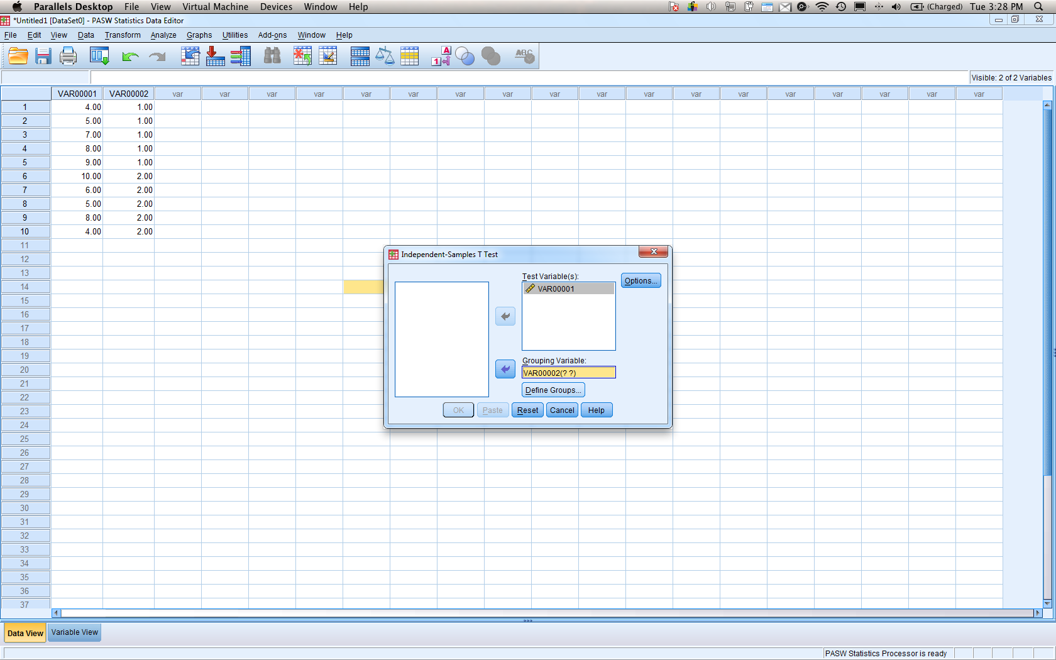
8. Now, you’ll need to define groups (see how it has ? ? marks).
   1. Hit define groups.
   2. Type in the group numbers that you used (here it’s 1 and 2).
   3. Hit continue and then ok:
9. 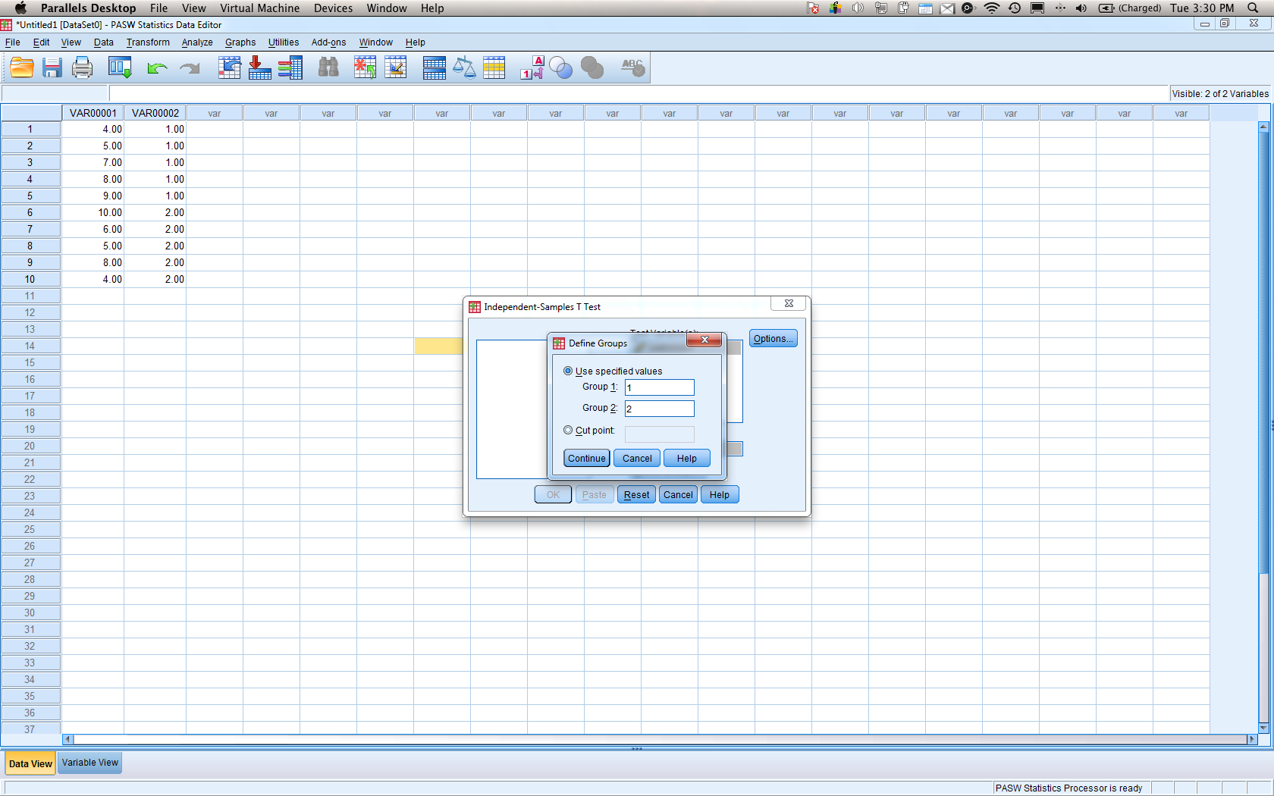

| **Group Statistics** | | | | | | |
| --- | --- | --- | --- | --- | --- | --- |
|  | VAR00002 | | N | Mean | Std. Deviation | Std. Error Mean |
| VAR00001 | dimension1 | 1.00 | 5 | 7.6000 | 3.20936 | 1.43527 |
| 2.00 | 5 | 5.8000 | 3.76829 | 1.68523 |

| **Independent Samples Test** | | | | | | | | | | |
| --- | --- | --- | --- | --- | --- | --- | --- | --- | --- | --- |
|  | | Levene's Test for Equality of Variances | | t-test for Equality of Means | | | | | | |
| F | Sig. | t | df | Sig. (2-tailed) | Mean Difference | Std. Error Difference | 95% Confidence Interval of the Difference | |
| Lower | Upper |
| VAR00001 | Equal variances assumed | .016 | .903 | .813 | 8 | .440 | 1.80000 | 2.21359 | -3.30456 | 6.90456 |
| Equal variances not assumed |  |  | .813 | 7.802 | .440 | 1.80000 | 2.21359 | -3.32716 | 6.92716 |

1. Var 001 is now split into the two different groups – hence the 1 row and the 2 row.
   1. N = number of people for each group.
   2. Mean = mean for each group.
   3. Std deviation – standard deviation for each sample group (S).
   4. St error of mean – Sm for each group.
2. Second box:
   1. Use the first line – equal variances assumed.
   2. Ignore the levene’s test.
   3. t = step 5 t value difference between sample groups.
   4. df = degrees of freedom. (N – 1 + N – 1)
   5. Mean difference – difference between group 1 and group 2 means.
   6. Std error difference = Sdifference – standard deviation pooled across both sample group.s
   7. 95% CI – upper and lower CI limits for Mdifference.